Task 3
Output
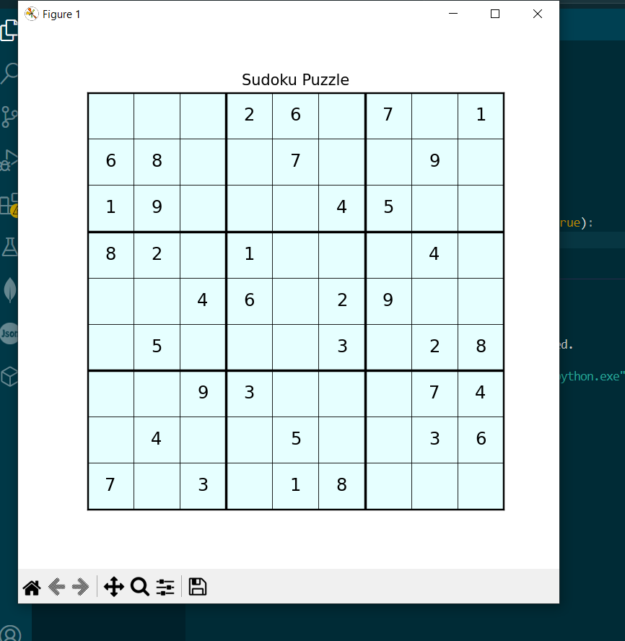

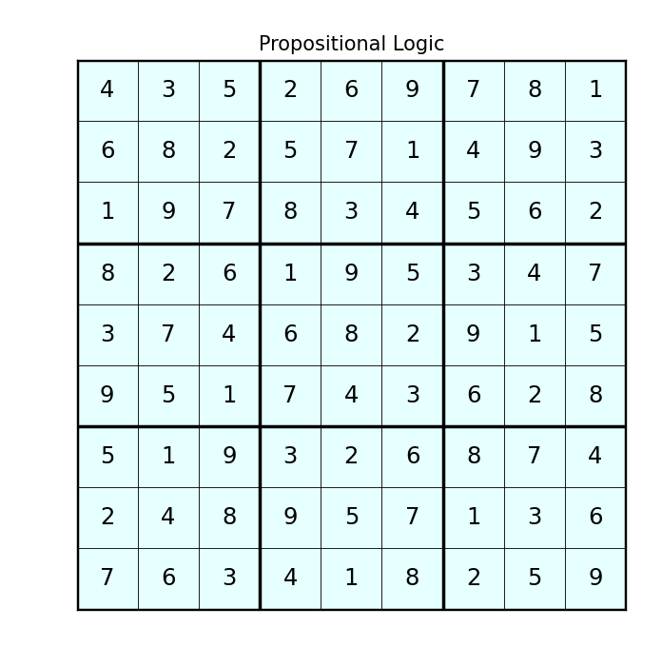
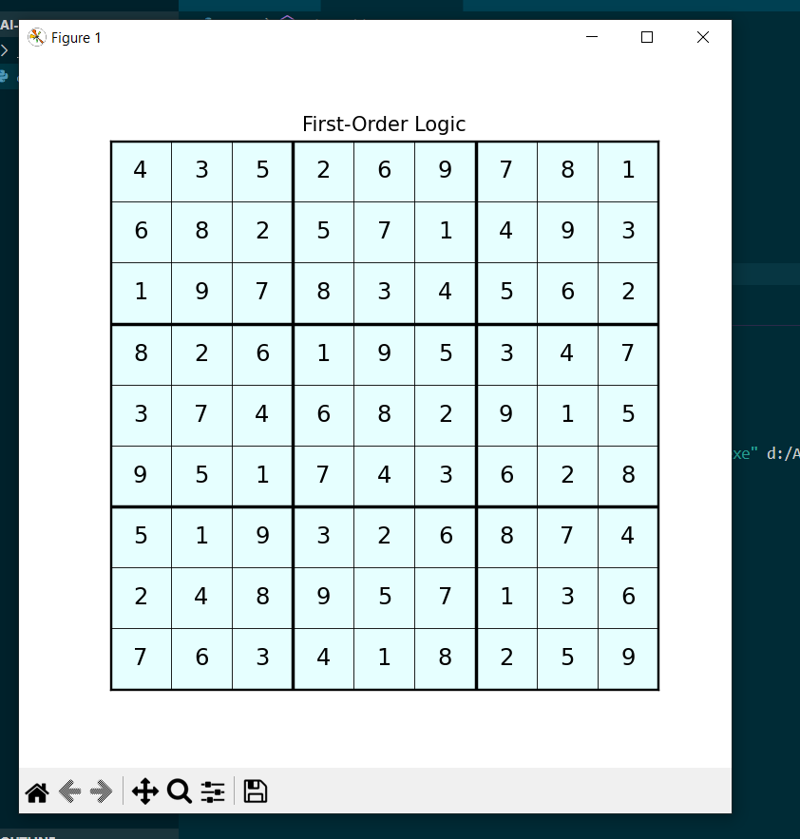

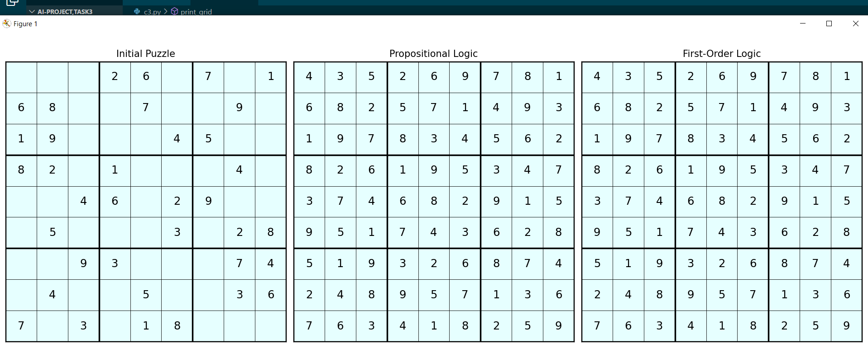

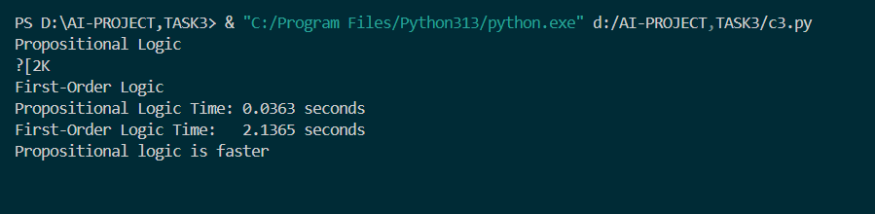

Code
import time
import pycosat
from z3 import *
import matplotlib.pyplot as plt
import numpy as np
from IPython.display import clear_output

# visualization

def print_grid(board, title="Sudoku", pause=True):
clear_output(wait=True)
plt.figure(figsize=(6, 6))
board_array = np.array(board)
plt.imshow(np.ones((9, 9)), cmap='cool', alpha=0.1)
for i in range(9):
for j in range(9):
if board[i][j] != 0:
plt.text(j, i, str(board[i][j]), ha='center', va='center', fontsize=14, color='black')
for i in range(10):
lw = 2 if i % 3 == 0 else 0.5
color = 'black'
plt.axhline(i - 0.5, color=color, linewidth=lw)
plt.axvline(i - 0.5, color=color, linewidth=lw)
plt.xticks([])
plt.yticks([])
plt.title(title)
plt.show()
if pause:
time.sleep(1) #slow

def print_all_boards(initial, prop, fol):
fig, axes = plt.subplots(1, 3, figsize=(18, 6))
titles = ["Initial Puzzle", "Propositional Logic", "First-Order Logic"]
boards = [initial, prop, fol]
for ax, board, title in zip(axes, boards, titles):
ax.imshow(np.ones((9, 9)), cmap='cool', alpha=0.1)
for i in range(9):
for j in range(9):
if board[i][j] != 0:
ax.text(j, i, str(board[i][j]), ha='center', va='center', fontsize=14, color='black')
for i in range(10):
lw = 2 if i % 3 == 0 else 0.5
ax.axhline(i - 0.5, color='black', linewidth=lw)
ax.axvline(i - 0.5, color='black', linewidth=lw)
ax.set_xticks([])
ax.set_yticks([])
ax.set_title(title)
plt.tight_layout()
plt.show()

# propositional

def encode_cellvalue(r, c, n):
return 81 * (r - 1) + 9 * (c - 1) + n

def sudoku_cnf():
cnf = []
for r in range(1, 10):
for c in range(1, 10):
cnf.append([encode_cellvalue(r, c, n) for n in range(1, 10)])
for n1 in range(1, 10):
for n2 in range(n1 + 1, 10):
cnf.append([-encode_cellvalue(r, c, n1), -encode_cellvalue(r, c, n2)])
for r in range(1, 10):
for n in range(1, 10):
cnf.append([encode_cellvalue(r, c, n) for c in range(1, 10)])
for c1 in range(1, 10):
for c2 in range(c1 + 1, 10):
cnf.append([-encode_cellvalue(r, c1, n), -encode_cellvalue(r, c2, n)])
for c in range(1, 10):
for n in range(1, 10):
cnf.append([encode_cellvalue(r, c, n) for r in range(1, 10)])
for r1 in range(1, 10):
for r2 in range(r1 + 1, 10):
cnf.append([-encode_cellvalue(r1, c, n), -encode_cellvalue(r2, c, n)])
for br in range(0, 3):
for bc in range(0, 3):
for n in range(1, 10):
block = []
for r in range(1 + br * 3, 4 + br * 3):
for c in range(1 + bc * 3, 4 + bc * 3):
block.append(encode_cellvalue(r, c, n))
cnf.append(block)
for i in range(len(block)):
for j in range(i + 1, len(block)):
cnf.append([-block[i], -block[j]])
return cnf

def encode_puzzle(puzzle):
clues = []
for r in range(9):
for c in range(9):
n = puzzle[r][c]
if n != 0:
clues.append([encode_cellvalue(r + 1, c + 1, n)])
return clues

def decode_solution(solution):
board = [[0] * 9 for _ in range(9)]
for val in solution:
if val > 0:
val -= 1
n = (val % 9) + 1
c = (val // 9) % 9
r = (val // 81)
board[r][c] = n
return board

def propositional(puzzle):
start = time.time()
cnf = sudoku_cnf() + encode_puzzle(puzzle)
solution = pycosat.solve(cnf)
if solution == "UNSAT":
print("No solution found (Propositional).")
return None, 0
board = decode_solution(solution)
end = time.time()
print_grid(board, "Propositional Logic")
return board, end - start

# first order logic

def fol(puzzle):
start = time.time()
time.sleep(1) # Simulated delay
X = [[Int(f"x_{r}_{c}") for c in range(9)] for r in range(9)]
s = Solver()
for r in range(9):
for c in range(9):
s.add(And(1 <= X[r][c], X[r][c] <= 9))
for r in range(9):
for c in range(9):
if puzzle[r][c] != 0:
s.add(X[r][c] == puzzle[r][c])
for r in range(9):
s.add(Distinct(X[r]))
for c in range(9):
s.add(Distinct([X[r][c] for r in range(9)]))
for br in range(0, 9, 3):
for bc in range(0, 9, 3):
block =[X[r][c] for r in range(br, br + 3) for c in range(bc, bc + 3)]
s.add(Distinct(block))
if s.check() == sat:
time.sleep(1)
m = s.model()
board = [[m.evaluate(X[r][c]).as_long() for c in range(9)] for r in range(9)]
end = time.time()
print_grid(board, "First-Order Logic")
return board, end - start
else:
print("No solution found (FOL).")
return None, 0

sudoku = [
[0, 0, 0, 2, 6, 0, 7, 0, 1],
[6, 8, 0, 0, 7, 0, 0, 9, 0],
[1, 9, 0, 0, 0, 4, 5, 0, 0],
[8, 2, 0, 1, 0, 0, 0, 4, 0],
[0, 0, 4, 6, 0, 2, 9, 0, 0],
[0, 5, 0, 0, 0, 3, 0, 2, 8],
[0, 0, 9, 3, 0, 0, 0, 7, 4],
[0, 4, 0, 0, 5, 0, 0, 3, 6],
[7, 0, 3, 0, 1, 8, 0, 0, 0]
]

print_grid(sudoku, "Sudoku Puzzle")

print("Propositional Logic")
prop_result, prop_time = propositional(sudoku)

print_grid(sudoku, "Sudoku Puzzle")
print("\nFirst-Order Logic")
fol_result, fol_time = fol(sudoku)

print(f"Propositional Logic Time: {prop_time:.4f} seconds")
print(f"First-Order Logic Time: {fol_time:.4f} seconds")

if prop_time < fol_time:
print("Propositional logic is faster")
else:
print("First-order logic is faster.")

if prop_result and fol_result:
print_all_boards(sudoku, prop_result, fol_result)

Task 4
Code & Output
# Import necessary libraries
import numpy as np
import pandas as pd
import matplotlib.pyplot as plt
import seaborn as sns
from sklearn.datasets import fetch_california_housing
from sklearn.model_selection import train_test_split
from sklearn.preprocessing import StandardScaler
from sklearn.linear_model import LinearRegression
from sklearn.neighbors import KNeighborsRegressor
from sklearn.metrics import r2_score, mean_absolute_error, mean_squared_error

california = fetch_california_housing()
X = pd.DataFrame(california.data, columns=california.feature_names)
y = pd.Series(california.target, name="MedHouseVal")

print("Dataset Features:")
print(X.head())
print("\nTarget Variable (Median House Value):")
print(y.head())

# Basic statistics
print("\nFeature Statistics:")
print(X.describe())

# Visualizations
plt.figure(figsize=(10, 6))
sns.histplot(y, kde=True)
plt.title("Distribution of Median House Values")
plt.xlabel("Median House Value (in $100,000s)")
plt.ylabel("Frequency")
plt.show()

# Correlation heatmap
plt.figure(figsize=(10, 8))
sns.heatmap(X.corr(), annot=True, cmap="coolwarm")
plt.title("Feature Correlation Matrix")
plt.show()

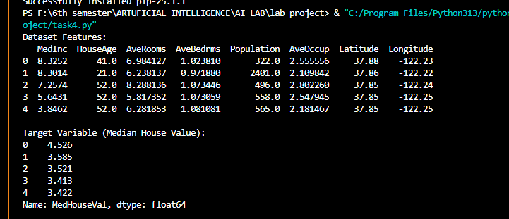

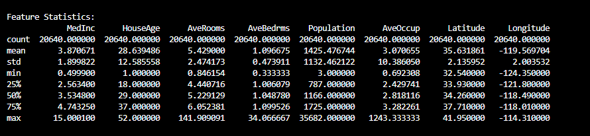
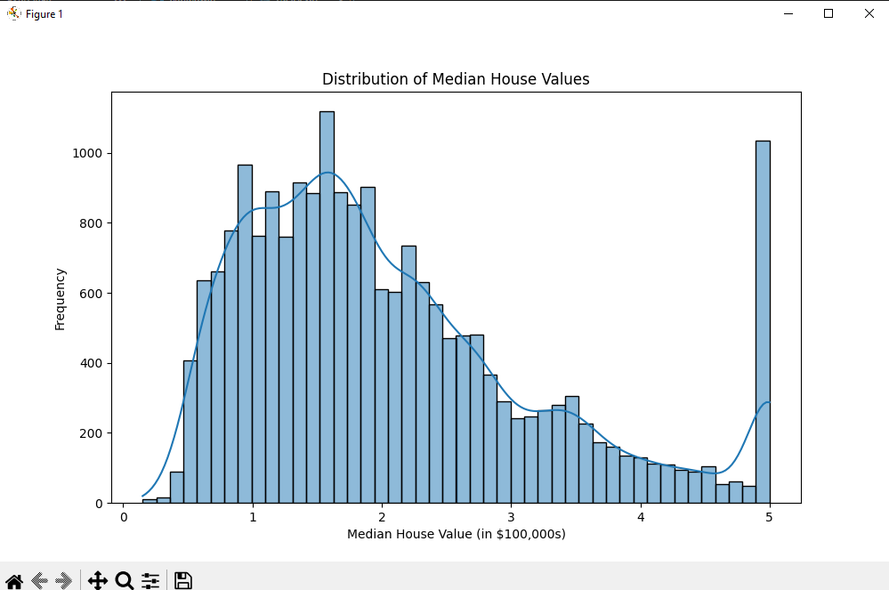

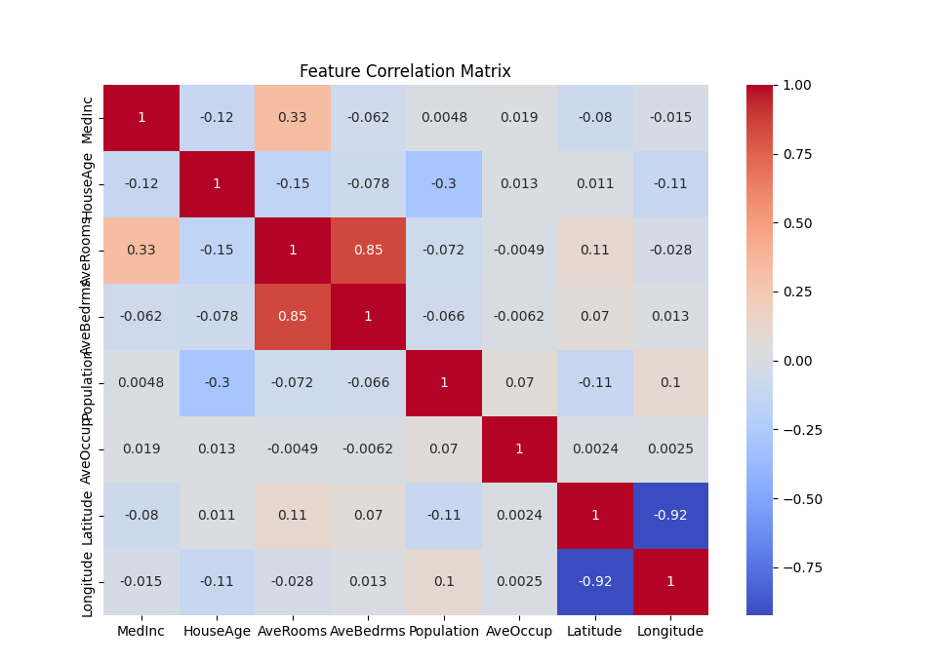

# Split dataset into 80% training, 20% testing
X_train, X_test, y_train, y_test = train_test_split(X, y, test_size=0.2, random_state=42)

# Standardize features (important for k-NN)
scaler = StandardScaler()
X_train_scaled = scaler.fit_transform(X_train)
X_test_scaled = scaler.transform(X_test)

# Train Linear Regression
lin_reg = LinearRegression()
lin_reg.fit(X_train, y_train)

# Predictions
y_pred_lin = lin_reg.predict(X_test)

# Model Coefficients
print("\nLinear Regression Coefficients:")
for feature, coef in zip(X.columns, lin_reg.coef_):
print(f"{feature}: {coef:.4f}")
print(f"Intercept: {lin_reg.intercept_:.4f}")

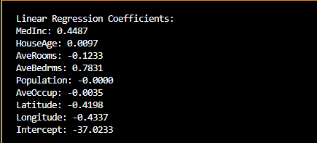

# Test different k-values (3, 5, 7)
knn_3 = KNeighborsRegressor(n_neighbors=3)
knn_5 = KNeighborsRegressor(n_neighbors=5)
knn_7 = KNeighborsRegressor(n_neighbors=7)

# Fit models
knn_3.fit(X_train_scaled, y_train)
knn_5.fit(X_train_scaled, y_train)
knn_7.fit(X_train_scaled, y_train)

# Predictions
y_pred_knn_3 = knn_3.predict(X_test_scaled)
y_pred_knn_5 = knn_5.predict(X_test_scaled)
y_pred_knn_7 = knn_7.predict(X_test_scaled)

def evaluate_model(y_true, y_pred, model_name):
r2 = r2_score(y_true, y_pred)
mae = mean_absolute_error(y_true, y_pred)
mse = mean_squared_error(y_true, y_pred)
print(f"\n{model_name} Performance:")
print(f"R² Score: {r2:.4f}")
print(f"MAE: {mae:.4f}")
print(f"MSE: {mse:.4f}")
return r2, mae, mse

# Evaluate Linear Regression
lin_r2, lin_mae, lin_mse = evaluate_model(y_test, y_pred_lin, "Linear Regression")

# Evaluate k-NN (k=3,5,7)
knn3_r2, knn3_mae, knn3_mse = evaluate_model(y_test, y_pred_knn_3, "k-NN (k=3)")
knn5_r2, knn5_mae, knn5_mse = evaluate_model(y_test, y_pred_knn_5, "k-NN (k=5)")
knn7_r2, knn7_mae, knn7_mse = evaluate_model(y_test, y_pred_knn_7, "k-NN (k=7)")

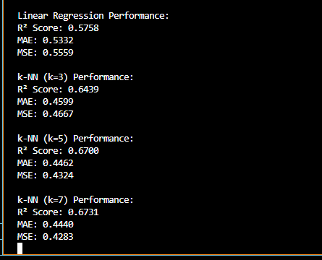

plt.figure(figsize=(12, 6))
sns.scatterplot(x=y_test, y=y_pred_lin, label="Linear Regression", alpha=0.6)
sns.scatterplot(x=y_test, y=y_pred_knn_5, label="k-NN (k=5)", alpha=0.6)
plt.plot([min(y_test), max(y_test)], [min(y_test), max(y_test)], 'r--', label="Perfect Prediction")
plt.xlabel("Actual Values")
plt.ylabel("Predicted Values")
plt.title("Actual vs. Predicted House Prices")
plt.legend()
plt.show()

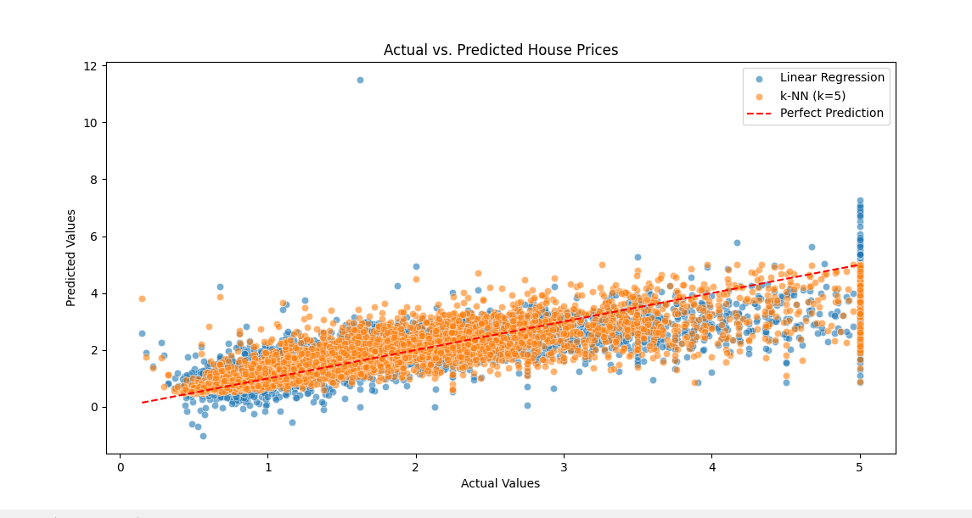

TASK 1
MAZE CODE
import numpy as np
import random
import time
from typing import List, Tuple, Dict
import heapq
from dataclasses import dataclass
from enum import Enum
import matplotlib.pyplot as plt
import matplotlib.colors as mcolors
from matplotlib.patches import Rectangle

class CellType(Enum):
EMPTY = 0
WALL = 1
TRAP = 2
EXIT = 3
LOCK = 4
START = 5

@dataclass
class Node:
position: Tuple[int, int]
parent: 'Node' = None
g_cost: float = 0 # Cost from start to current
h_cost: float = 0 # Heuristic cost to goal
f_cost: float = 0 # Total cost (g_cost + h_cost)

def __lt__(self, other):
return self.f_cost < other.f_cost

class Maze:
def __init__(self, size: int = 15):
self.size = size
self.grid = np.zeros((size, size), dtype=int)
self.start_pos = None
self.exit_pos = None
self.generate_maze()

def generate_maze(self):
# Initialize with walls
self.grid.fill(CellType.WALL.value)

# Create a path using depth-first search
stack = [(1, 1)]
self.grid[1, 1] = CellType.EMPTY.value

while stack:
current = stack[-1]
neighbors = self.get_unvisited_neighbors(current)

if neighbors:
next_cell = random.choice(neighbors)
# Remove wall between current and next
wall_pos = ((current[0] + next_cell[0]) // 2,
(current[1] + next_cell[1]) // 2)
self.grid[wall_pos] = CellType.EMPTY.value
self.grid[next_cell] = CellType.EMPTY.value
stack.append(next_cell)
else:
stack.pop()

# Add traps (10% of empty cells)
empty_cells = np.where(self.grid == CellType.EMPTY.value)
trap_count = int(len(empty_cells[0]) * 0.1)
trap_indices = random.sample(range(len(empty_cells[0])), trap_count)
for idx in trap_indices:
self.grid[empty_cells[0][idx], empty_cells[1][idx]] = CellType.TRAP.value

# Add locks (5% of empty cells)
empty_cells = np.where(self.grid == CellType.EMPTY.value)
lock_count = int(len(empty_cells[0]) * 0.05)
lock_indices = random.sample(range(len(empty_cells[0])), lock_count)
for idx in lock_indices:
self.grid[empty_cells[0][idx], empty_cells[1][idx]] = CellType.LOCK.value

# Set start and exit positions
self.set_start_and_exit()

def get_unvisited_neighbors(self, pos: Tuple[int, int]) -> List[Tuple[int, int]]:
neighbors = []
directions = [(0, 2), (2, 0), (0, -2), (-2, 0)]

for dx, dy in directions:
new_x, new_y = pos[0] + dx, pos[1] + dy
if (0 < new_x < self.size-1 and 0 < new_y < self.size-1 and
self.grid[new_x, new_y] == CellType.WALL.value):
neighbors.append((new_x, new_y))

return neighbors

def set_start_and_exit(self):

empty_cells = np.where(self.grid == CellType.EMPTY.value)
empty_positions = list(zip(empty_cells[0], empty_cells[1]))

self.start_pos = random.choice(empty_positions)
self.grid[self.start_pos] = CellType.START.value

empty_positions.remove(self.start_pos)
self.exit_pos = random.choice(empty_positions)
self.grid[self.exit_pos] = CellType.EXIT.value

def get_neighbors(self, pos: Tuple[int, int]) -> List[Tuple[int, int]]:
neighbors = []
directions = [(0, 1), (1, 0), (0, -1), (-1, 0)]

for dx, dy in directions:
new_x, new_y = pos[0] + dx, pos[1] + dy
if (0 <= new_x < self.size and 0 <= new_y < self.size and
self.grid[new_x, new_y] != CellType.WALL.value):
neighbors.append((new_x, new_y))

return neighbors

def get_cost(self, pos: Tuple[int, int]) -> float:
cell_type = self.grid[pos]
if cell_type == CellType.TRAP.value:
return random.uniform(10, 20)
return 1.0

def visualize(self, path: List[Tuple[int, int]] = None):
# Create a figure and axis
fig, ax = plt.subplots(figsize=(10, 10))

colors = {
CellType.EMPTY.value: '#ffffff', # White
CellType.WALL.value: '#0000ff', # Blue
CellType.TRAP.value: '#ff6666', # Bright red
CellType.EXIT.value: '#00ff00', # Bright green
CellType.LOCK.value: '#ff33ff', # Magenta
CellType.START.value: '#800080' # Purple
}

cmap = mcolors.ListedColormap([colors[i] for i in range(len(colors))])

ax.imshow(self.grid, cmap=cmap, vmin=0, vmax=len(colors)-1)

if path:
path_x = [p[1] for p in path] # x coordinates
path_y = [p[0] for p in path] # y coordinates
ax.plot(path_x, path_y, 'yellow', linewidth=2, label='Path')

ax.set_xticks(np.arange(-0.5, self.size, 1))
ax.set_yticks(np.arange(-0.5, self.size, 1))
ax.grid(which='major', color='gray', linestyle='-', linewidth=0.5)
ax.set_xticklabels([])
ax.set_yticklabels([])

legend_elements = [
Rectangle((0, 0), 1, 1, facecolor=colors[CellType.EMPTY.value], edgecolor='black', label='Empty'),
Rectangle((0, 0), 1, 1, facecolor=colors[CellType.WALL.value], edgecolor='black', label='Wall'),
Rectangle((0, 0), 1, 1, facecolor=colors[CellType.TRAP.value], edgecolor='black', label='Trap'),
Rectangle((0, 0), 1, 1, facecolor=colors[CellType.EXIT.value], edgecolor='black', label='Exit'),
Rectangle((0, 0), 1, 1, facecolor=colors[CellType.LOCK.value], edgecolor='black', label='Lock'),
Rectangle((0, 0), 1, 1, facecolor=colors[CellType.START.value], edgecolor='black', label='Start')
]
if path:
legend_elements.append(plt.Line2D([0], [0], color='yellow', linewidth=2, label='Path'))

ax.legend(handles=legend_elements, bbox_to_anchor=(1.05, 1), loc='upper left')

plt.tight_layout()
plt.show()

class AStarSolver:
def __init__(self, maze: Maze):
self.maze = maze
self.open_set = []
self.closed_set = set()
self.start_node = Node(maze.start_pos)
self.goal_node = Node(maze.exit_pos)

def heuristic(self, pos: Tuple[int, int]) -> float:
# Manhattan distance
return abs(pos[0] - self.goal_node.position[0]) + abs(pos[1] - self.goal_node.position[1])

def solve(self) -> List[Tuple[int, int]]:
self.start_node.h_cost = self.heuristic(self.start_node.position)
self.start_node.f_cost = self.start_node.h_cost
heapq.heappush(self.open_set, self.start_node)

while self.open_set:
current_node = heapq.heappop(self.open_set)

if current_node.position == self.goal_node.position:
return self.reconstruct_path(current_node)

self.closed_set.add(current_node.position)

for neighbor_pos in self.maze.get_neighbors(current_node.position):
if neighbor_pos in self.closed_set:
continue

neighbor_node = Node(neighbor_pos, current_node)
neighbor_node.g_cost = current_node.g_cost + self.maze.get_cost(neighbor_pos)
neighbor_node.h_cost = self.heuristic(neighbor_pos)
neighbor_node.f_cost = neighbor_node.g_cost + neighbor_node.h_cost

# Check if this path to neighbor is better
existing_node = next((node for node in self.open_set if node.position == neighbor_pos), None)
if existing_node and existing_node.g_cost <= neighbor_node.g_cost:
continue

if existing_node:
self.open_set.remove(existing_node)
heapq.heappush(self.open_set, neighbor_node)

return [] # No path found

def reconstruct_path(self, node: Node) -> List[Tuple[int, int]]:
path = []
current = node
while current:
path.append(current.position)
current = current.parent
return path[::-1]

def evaluate_performance(maze: Maze, path: List[Tuple[int, int]]) -> Dict:
if not path:
return {
"path_found": False,
"total_steps": 0,
"total_cost": 0,
"time_complexity": "O(b^d)",
"space_complexity": "O(b^d)"
}

total_cost = sum(maze.get_cost(pos) for pos in path[1:]) # Exclude start position
return {
"path_found": True,
"total_steps": len(path) - 1, # Exclude start position
"total_cost": total_cost,
"time_complexity": "O(b^d)", # b = branching factor, d = depth
"space_complexity": "O(b^d)"
}

def main():
# Run 3 maze escape tasks
for i in range(3):
print(f"\nMaze Escape Task {i+1}")
print("=" * 50)

# Create and solve maze
maze = Maze()
solver = AStarSolver(maze)

start_time = time.time()
path = solver.solve()
end_time = time.time()

# Evaluate performance
performance = evaluate_performance(maze, path)

# Print results
print(f"Start Position: {maze.start_pos}")
print(f"Exit Position: {maze.exit_pos}")
print(f"Path Found: {'Yes' if path else 'No'}")
if path:
print(f"Path Length: {len(path)}")
print(f"Total Cost: {performance['total_cost']:.2f}")
print(f"Time Taken: {end_time - start_time:.4f} seconds")
print(f"Time Complexity: {performance['time_complexity']}")
print(f"Space Complexity: {performance['space_complexity']}")

# Visualize the maze and path
print("\nVisualizing maze and path...")
maze.visualize(path)

# Wait for user to press Enter before showing next maze
if i < 2: # Don't wait after the last maze
input("\nPress Enter to continue to the next maze...")

if __name__ == "__main__":
main()

OUTPUT:
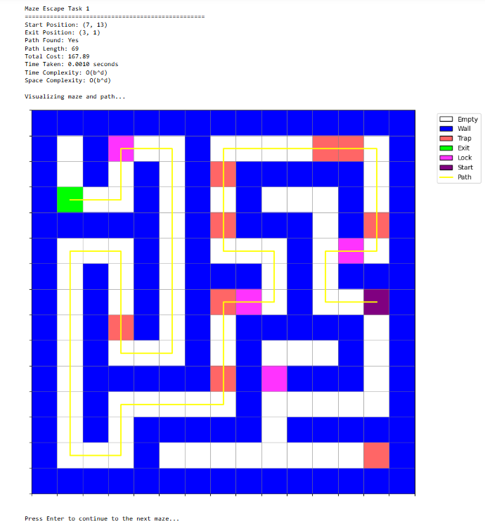
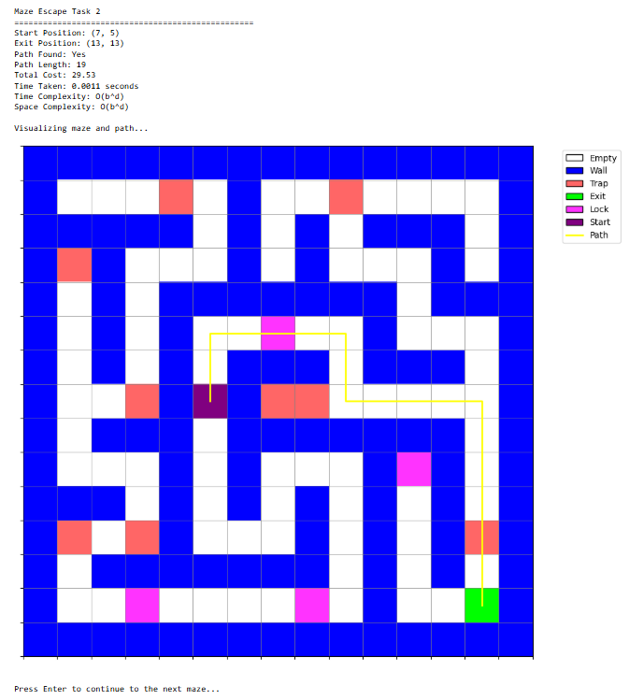
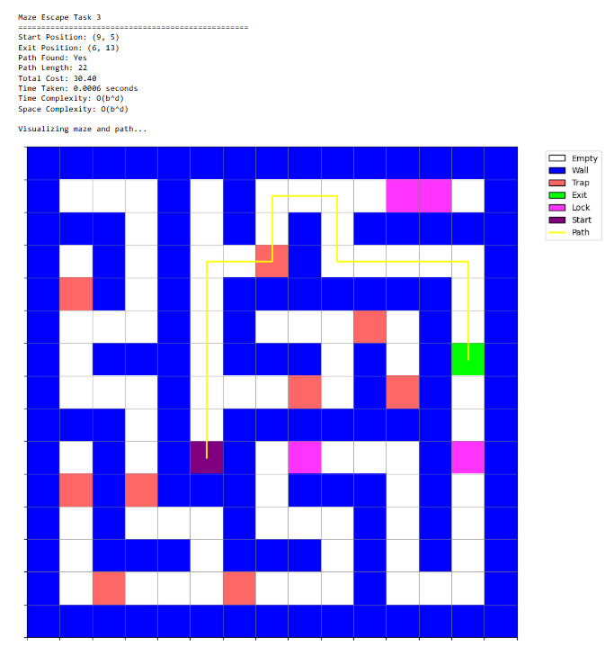

TASK 2
CODE
import numpy as np
import matplotlib.pyplot as plt
import matplotlib.patches as patches
import matplotlib.animation as animation
import matplotlib.patheffects as PathEffects
from collections import deque
import time
import random

# Constants for light states
RED = 'RED'
GREEN = 'GREEN'
YELLOW = 'YELLOW'

# Number of intersections in a 4x5 grid (20 intersections)
ROWS, COLS = 4, 5
INTERSECTION_IDS = [f'I{i+1}' for i in range(ROWS*COLS)]

# Example traffic volume placeholder for each intersection
np.random.seed(42) # For reproducibility
traffic_volumes = np.random.randint(20, 80, size=(ROWS, COLS))

# Emergency vehicle presence flags per intersection (True/False)
emergency_flags = np.zeros((ROWS, COLS), dtype=bool)
for c in range(COLS):
emergency_flags[0, c] = (c % 3 == 0) # Emergency vehicles at some intersections in first row

# Bus route flags per intersection (True/False)
bus_flags = np.zeros((ROWS, COLS), dtype=bool)
bus_flags[:, COLS // 2] = True # Bus route in the middle column

# Add pedestrian crossings at every intersection
pedestrian_flags = np.ones((ROWS, COLS), dtype=bool) # All intersections have pedestrian crossings

GREEN_MIN, GREEN_MAX = 15, 60
YELLOW_MIN, YELLOW_MAX = 3, 6
RED_MIN, RED_MAX = 30, 90

MAX_WAIT_CYCLES = 3

GREEN_PHASE_DURATION = 30
YELLOW_PHASE_DURATION = 5
CYCLE_DURATION = GREEN_PHASE_DURATION + YELLOW_PHASE_DURATION

# Weather condition (True if raining)
is_raining = False # Start with no rain; can toggle later or randomize

# Add vehicle positions for visualization
class Vehicle:
def __init__(self, x, y, vehicle_type='car', direction='horizontal'):
self.x = x
self.y = y
self.vehicle_type = vehicle_type # 'car', 'bus', or 'ambulance'
self.direction = direction # 'horizontal' or 'vertical'
self.moved = False
self.speed = 0.02
if vehicle_type == 'ambulance':
self.speed = 0.03 # Ambulance moves faster
elif vehicle_type == 'bus':
self.speed = 0.015 # Bus moves slower
# For speed tracking
self.prev_x = x
self.prev_y = y
self.actual_speed = self.speed
self.time_since_last_update = 0
# For vehicle chains and green wave tracking
self.chain_id = None # Will be assigned if part of a vehicle chain
self.stops = 0 # Count number of stops (for fuel consumption tracking)

class Pedestrian:
def __init__(self, x, y, direction='horizontal'):
self.x = x
self.y = y
self.direction = direction
self.crossing = False
self.speed = 0.01
self.waiting = True

# New classes for soft constraints implementation
class VehicleChain:
def __init__(self, chain_id):
self.id = chain_id
self.vehicles = []
self.direction = None # 'horizontal' or 'vertical'
self.route = [] # List of intersections in the path
self.priority_score = 0 # Higher score = higher priority for green wave

def add_vehicle(self, vehicle):
self.vehicles.append(vehicle)
vehicle.chain_id = self.id

def get_size(self):
return len(self.vehicles)

def calculate_priority(self):
# Chains with more vehicles get higher priority
size_factor = len(self.vehicles) * 0.5

# Chains with buses or emergency vehicles get higher priority
has_bus = any(v.vehicle_type == 'bus' for v in self.vehicles)
has_emergency = any(v.vehicle_type == 'ambulance' for v in self.vehicles)

special_factor = 1.0
if has_bus:
special_factor += 0.5
if has_emergency:
special_factor += 1.0

# Calculate priority score
self.priority_score = size_factor * special_factor
return self.priority_score

class DistrictManager:
def __init__(self, rows, cols):
self.rows = rows
self.cols = cols
# Define districts (assume 4 districts in a 2x2 grid for simplicity)
self.districts = {}
# Top-left district
self.districts[0] = [(r, c) for r in range(rows//2) for c in range(cols//2)]
# Top-right district
self.districts[1] = [(r, c) for r in range(rows//2) for c in range(cols//2, cols)]
# Bottom-left district
self.districts[2] = [(r, c) for r in range(rows//2, rows) for c in range(cols//2)]
# Bottom-right district
self.districts[3] = [(r, c) for r in range(rows//2, rows) for c in range(cols//2, cols)]

# Track green time allocation per district
self.green_time_allocation = {i: 0 for i in range(len(self.districts))}
# Track average congestion per district
self.district_congestion = {i: 0 for i in range(len(self.districts))}
# Track fairness metrics
self.fairness_scores = {i: 0 for i in range(len(self.districts))}

def update_green_time(self, r, c, green_duration):
"""Track green time given to each district"""
for district_id, intersections in self.districts.items():
if (r, c) in intersections:
self.green_time_allocation[district_id] += green_duration
break

def update_congestion(self, traffic_data):
"""Calculate average congestion for each district"""
for district_id, intersections in self.districts.items():
total_congestion = 0
for r, c in intersections:
total_congestion += traffic_data.congestion_levels[r, c]
self.district_congestion[district_id] = total_congestion / len(intersections)

def calculate_fairness(self):
"""Calculate fairness scores based on green time allocation vs. congestion level"""
total_green_time = sum(self.green_time_allocation.values()) or 1 # Avoid division by zero
total_congestion = sum(self.district_congestion.values()) or 1

for district_id in self.districts:
# Normalized green time for this district
green_share = self.green_time_allocation[district_id] / total_green_time
# Normalized congestion for this district
congestion_share = self.district_congestion[district_id] / total_congestion

# Fairness score: 1.0 means perfect fairness (green time proportional to congestion)
# <1.0 means district is getting less green time than its congestion warrants
# >1.0 means district is getting more green time than its congestion warrants
self.fairness_scores[district_id] = green_share / congestion_share if congestion_share > 0 else 1.0

def get_fairness_adjustment(self, r, c):
"""Get adjustment factor for green time based on fairness"""
for district_id, intersections in self.districts.items():
if (r, c) in intersections:
fairness = self.fairness_scores[district_id]
# If fairness < 1, district needs more green time
if fairness < 0.8:
return 1.2 # Increase green time
# If fairness > 1, district is getting more than its fair share
elif fairness > 1.2:
return 0.9 # Decrease green time
else:
return 1.0 # No adjustment
return 1.0

class FuelConsumptionTracker:
def __init__(self):
self.total_consumption = 0
self.vehicle_stops = {} # Track stops per vehicle
self.consumption_history = deque(maxlen=100)

def track_vehicle_stop(self, vehicle):
"""Track when vehicles stop (causes higher fuel consumption)"""
if id(vehicle) not in self.vehicle_stops:
self.vehicle_stops[id(vehicle)] = 0
self.vehicle_stops[id(vehicle)] += 1

def calculate_consumption(self, vehicles, traffic_data):
"""Calculate approximate fuel consumption based on stops and traffic patterns"""
# Base consumption (vehicles x distance)
base_consumption = len(vehicles) * 0.1

# Additional consumption from stops (stop-and-go traffic)
stop_consumption = sum(self.vehicle_stops.values()) * 0.5

# Additional consumption from congestion
congestion_factor = np.mean(traffic_data.congestion_levels)
congestion_consumption = congestion_factor * len(vehicles) * 0.3

# Total consumption
current_consumption = base_consumption + stop_consumption + congestion_consumption
self.total_consumption += current_consumption
self.consumption_history.append(current_consumption)

# Reset stop counter for next cycle
self.vehicle_stops = {}

return current_consumption

# New class for real-time traffic data
class TrafficData:
def __init__(self, rows, cols):
self.rows = rows
self.cols = cols
# Initialize data structures for each intersection
self.vehicle_counts = np.zeros((rows, cols)) # Count of vehicles at each intersection
self.avg_speeds = np.ones((rows, cols)) * 0.02 # Average speed of vehicles (normalized between 0-1)
self.congestion_levels = np.zeros((rows, cols)) # Congestion level (0-1 scale)

# History tracking for visualization
self.history_length = 50
self.vehicle_count_history = {(r, c): deque(maxlen=self.history_length)
for r in range(rows) for c in range(cols)}
self.speed_history = {(r, c): deque(maxlen=self.history_length)
for r in range(rows) for c in range(cols)}
self.congestion_history = {(r, c): deque(maxlen=self.history_length)
for r in range(rows) for c in range(cols)}

# Initialize with some data
self.generate_initial_data()

def generate_initial_data(self):
"""Generate initial traffic data with some randomization"""
for r in range(self.rows):
for c in range(self.cols):
# More vehicles in central intersections
base_count = 10 + 5 * (min(r, self.rows-1-r) + min(c, self.cols-1-c))
self.vehicle_counts[r, c] = np.random.randint(
max(1, base_count - 5),
base_count + 5
)

# Speeds are generally higher in peripheral areas
center_distance = np.sqrt((r - self.rows/2)*2 + (c - self.cols/2)*2)
max_distance = np.sqrt((self.rows/2)*2 + (self.cols/2)*2)
peripheral_factor = center_distance / max_distance # 0 at center, 1 at periphery

self.avg_speeds[r, c] = 0.01 + 0.02 * peripheral_factor + 0.005 * np.random.random()

# Congestion is inverse of speed but with some randomness
self.congestion_levels[r, c] = 1 - peripheral_factor * 0.8 + 0.2 * np.random.random()

# Store initial values in history
self.vehicle_count_history[(r, c)].append(self.vehicle_counts[r, c])
self.speed_history[(r, c)].append(self.avg_speeds[r, c])
self.congestion_history[(r, c)].append(self.congestion_levels[r, c])

def update_data(self, vehicles, intersections, global_time, weather_rain):
"""Update traffic data based on current vehicles and intersection states"""
# Calculate time of day factor for traffic volume/rush hour influence
# Simulate a day with period 1200 frames (~2 minutes at 100ms per frame)
day_period = 1200
time_in_day = global_time % day_period
# Rush hour peaks around time_in_day = 300 and 900 (morning and evening)
morning_peak = np.exp(-((time_in_day - 300) / 100)**2)
evening_peak = np.exp(-((time_in_day - 900) / 100)**2)
time_of_day_factor = 0.7 + 0.6 * (morning_peak + evening_peak) # Ranges from 0.7 to ~1.9

# Reset counts for a new count
new_counts = np.zeros((self.rows, self.cols))
new_speeds = np.zeros((self.rows, self.cols))
vehicle_counts_per_intersection = np.zeros((self.rows, self.cols))

# Count vehicles at each intersection and calculate speeds
for vehicle in vehicles:
# Get the nearest intersection
nearest_r = int(round(vehicle.y))
nearest_c = int(round(vehicle.x))

if 0 <= nearest_r < self.rows and 0 <= nearest_c < self.cols:
new_counts[nearest_r, nearest_c] += 1
new_speeds[nearest_r, nearest_c] += vehicle.actual_speed
vehicle_counts_per_intersection[nearest_r, nearest_c] += 1

# Calculate average speeds
for r in range(self.rows):
for c in range(self.cols):
# Modulate base counts by time of day factor mimicking rush hour
base_vehicle_count = new_counts[r, c] * time_of_day_factor
# Update vehicle counts with smoothing and noise
self.vehicle_counts[r, c] = 0.7 * self.vehicle_counts[r, c] + 0.3 * base_vehicle_count

# Update average speeds
if vehicle_counts_per_intersection[r, c] > 0:
current_avg_speed = new_speeds[r, c] / vehicle_counts_per_intersection[r, c]
self.avg_speeds[r, c] = 0.7 * self.avg_speeds[r, c] + 0.3 * current_avg_speed

# Add random fluctuations for realism
self.vehicle_counts[r, c] += np.random.normal(0, 0.5)
self.avg_speeds[r, c] += np.random.normal(0, 0.001)

# Ensure values are within bounds
self.vehicle_counts[r, c] = max(0, self.vehicle_counts[r, c])
self.avg_speeds[r, c] = max(0.005, min(0.05, self.avg_speeds[r, c]))

# Calculate congestion based on vehicle count and signal state
# Higher count + red signal = more congestion
base_congestion = min(1.0, self.vehicle_counts[r, c] / 20.0)
if intersections[r][c].state == RED:
base_congestion *= 1.5

# Apply time of day factor to congestion too
new_congestion = base_congestion * time_of_day_factor

# Smooth congestion data
self.congestion_levels[r, c] = 0.8 * self.congestion_levels[r, c] + 0.2 * new_congestion
self.congestion_levels[r, c] = min(1.0, max(0.0, self.congestion_levels[r, c]))

# Add to history
self.vehicle_count_history[(r, c)].append(self.vehicle_counts[r, c])
self.speed_history[(r, c)].append(self.avg_speeds[r, c])
self.congestion_history[(r, c)].append(self.congestion_levels[r, c])

def get_adaptive_timing_factor(self, r, c):
"""Calculate a factor to adjust signal timings based on traffic conditions"""
# Higher congestion = longer green time for that approach
congestion = self.congestion_levels[r, c]
vehicle_count = self.vehicle_counts[r, c]

# Basic adaptive factor based on congestion and vehicle count
adaptive_factor = 1.0 + congestion * 0.5 + min(1.0, vehicle_count / 15) * 0.5

return adaptive_factor

def get_city_congestion_balance(self):
"""Calculate how evenly congestion is distributed across the city"""
# Calculate variance of congestion levels
congestion_variance = np.var(self.congestion_levels)
# Higher variance means more uneven congestion distribution
return congestion_variance

class Intersection:
def __init__(self, row, col):
self.id = f'I{row * COLS + col + 1}'
self.row = row
self.col = col
self.green_duration = GREEN_PHASE_DURATION
self.yellow_duration = YELLOW_PHASE_DURATION
self.red_duration = 0
self.state = RED
self.priority = False
self.wait_cycles = 0
self.consecutive_red_cycles = 0 # Track consecutive red cycles for vehicles waiting
self.has_pedestrian_crossing = pedestrian_flags[row, col]
# For adaptive timing
self.base_green_duration = GREEN_PHASE_DURATION
self.adaptive_factor = 1.0
# For soft constraints
self.green_wave_priority = 0
self.fairness_adjustment = 1.0
self.congestion_balance_adjustment = 1.0
# For fuel consumption optimization
self.stop_count = 0
# For tracking when a vehicle had to stop
self.vehicles_stopped = set()
# Track total green time for fairness
self.total_green_time = 0

def __repr__(self):
base_info = (f"{self.id} - G:{self.green_duration}s, Y:{self.yellow_duration}s, R:{self.red_duration}s, "
f"State: {self.state}, Priority: {self.priority}")
return base_info

def update_timings(self, factor, green_wave_priority=0, fairness_adj=1.0, congestion_adj=1.0):
"""Update signal timings based on various factors"""
self.adaptive_factor = factor
self.green_wave_priority = green_wave_priority
self.fairness_adjustment = fairness_adj
self.congestion_balance_adjustment = congestion_adj

# Combined adjustment factor with various soft constraints
combined_factor = (
factor *
(1.0 + green_wave_priority * 0.3) *
fairness_adj *
congestion_adj
)

# Adjust green time based on factor with limits
self.green_duration = min(GREEN_MAX, max(GREEN_MIN,
int(self.base_green_duration * combined_factor)))

class TrafficSignalSystem:
def __init__(self):
self.intersections = [[Intersection(r, c) for c in range(COLS)] for r in range(ROWS)]
self.global_time = 0
self.configure_priorities()
# Initialize vehicles and pedestrians
self.vehicles = []
self.pedestrians = []
self.initialize_vehicles()
self.initialize_pedestrians()
# Initialize real-time traffic data
self.traffic_data = TrafficData(ROWS, COLS)
# For data display
self.current_focus = (0, 0) # Current intersection to show detailed data for
self.show_data_overlay = True
# Weather condition: Initially no rain
self.is_raining = False
self.rain_toggle_interval = 500 # Toggle rain roughly every 500 frames on average
# For soft constraints
self.vehicle_chains = [] # For green wave coordination
self.district_manager = DistrictManager(ROWS, COLS) # For fairness across districts
self.fuel_tracker = FuelConsumptionTracker() # For fuel consumption optimization
# For identification of vehicle chains
self.next_chain_id = 1
self.chain_detection_interval = 50 # Detect chains every 50 frames
# For tracking congestion balance
self.congestion_balance_history = deque(maxlen=50)

def toggle_rain(self):
# Randomly toggle rain condition roughly every rain_toggle_interval frames
if np.random.rand() < 1.0 / self.rain_toggle_interval:
self.is_raining = not self.is_raining
print(f"Weather changed: {'Raining' if self.is_raining else 'Clear'}")

def initialize_vehicles(self):
# Add cars and buses at specific locations as shown in the image
self.vehicles.append(Vehicle(1.3, 0.8, 'car', 'horizontal')) # Car near I2
self.vehicles.append(Vehicle(4.2, 2.2, 'bus', 'vertical')) # Bus near I15
self.vehicles.append(Vehicle(0.7, 0.3, 'ambulance', 'horizontal')) # Ambulance near I1

# Add more vehicles for visual interest
self.vehicles.append(Vehicle(0.2, 3.2, 'car', 'horizontal'))
self.vehicles.append(Vehicle(3.7, 1.8, 'car', 'vertical'))

# Add more vehicles randomly
for _ in range(15):
if np.random.random() < 0.5:
# Horizontal vehicle
x = np.random.uniform(-0.5, COLS + 0.5)
y = np.random.randint(0, ROWS) + np.random.uniform(-0.3, 0.3)
direction = 'horizontal'
else:
# Vertical vehicle
x = np.random.randint(0, COLS) + np.random.uniform(-0.3, 0.3)
y = np.random.uniform(-0.5, ROWS + 0.5)
direction = 'vertical'

vehicle_type = np.random.choice(['car', 'car', 'car', 'bus'], p=[0.8, 0.1, 0.05, 0.05])
self.vehicles.append(Vehicle(x, y, vehicle_type, direction))

def initialize_pedestrians(self):
# Add pedestrians at every intersection
for r in range(ROWS):
for c in range(COLS):
# Add pedestrians on all sides of each crossing
self.pedestrians.append(Pedestrian(c - 0.2, r, 'horizontal')) # Left side
self.pedestrians.append(Pedestrian(c + 0.2, r, 'horizontal')) # Right side
self.pedestrians.append(Pedestrian(c, r - 0.2, 'vertical')) # Bottom side
self.pedestrians.append(Pedestrian(c, r + 0.2, 'vertical')) # Top side

def configure_priorities(self):
for r in range(ROWS):
for c in range(COLS):
if emergency_flags[r, c] or bus_flags[r, c]:
self.intersections[r][c].priority = True

def has_conflict(self, r, c):
for i in range(ROWS):
if i != r and self.intersections[i][c].state == GREEN:
return True
for j in range(COLS):
if j != c and self.intersections[r][j].state == GREEN:
return True
return False

def detect_vehicle_chains(self):
"""Identify chains of vehicles moving together on same direction"""
# Reset all vehicle chain IDs
for vehicle in self.vehicles:
vehicle.chain_id = None

# Clear existing chains
self.vehicle_chains = []

# Group vehicles by direction and proximity
horizontal_vehicles = [v for v in self.vehicles if v.direction == 'horizontal']
vertical_vehicles = [v for v in self.vehicles if v.direction == 'vertical']

# Sort by x or y position
horizontal_vehicles.sort(key=lambda v: v.x)
vertical_vehicles.sort(key=lambda v: v.y)

# Detect horizontal chains
self._create_chains(horizontal_vehicles, 'horizontal')

# Detect vertical chains
self._create_chains(vertical_vehicles, 'vertical')

# Calculate priority scores for all chains
for chain in self.vehicle_chains:
chain.calculate_priority()

def _create_chains(self, sorted_vehicles, direction):
"""Helper to create vehicle chains from sorted vehicles list"""
if not sorted_vehicles:
return

proximity_threshold = 0.5 # Vehicles closer than this are in the same chain

# Start first chain
current_chain = VehicleChain(self.next_chain_id)
self.next_chain_id += 1
current_chain.direction = direction

current_chain.add_vehicle(sorted_vehicles[0])
self.vehicle_chains.append(current_chain)

# Check each vehicle against the previous one
for i in range(1, len(sorted_vehicles)):
current = sorted_vehicles[i]
previous = sorted_vehicles[i-1]

if direction == 'horizontal':
dist = abs(current.x - previous.x)
else:
dist = abs(current.y - previous.y)

if dist <= proximity_threshold:
# Add to existing chain
current_chain.add_vehicle(current)
else:
# Start new chain
current_chain = VehicleChain(self.next_chain_id)
self.next_chain_id += 1
current_chain.direction = direction
current_chain.add_vehicle(current)
self.vehicle_chains.append(current_chain)

def get_green_wave_priority(self, r, c):
"""Calculate priority for green wave coordination for an intersection"""
intersection = self.intersections[r][c]

# Check if any vehicle chain is near this intersection
priority = 0

for chain in self.vehicle_chains:
if chain.get_size() < 3: # Only consider chains of 3+ vehicles
continue

# Determine if the chain is passing through this intersection
chain_at_intersection = False

for vehicle in chain.vehicles:
nearest_r = int(round(vehicle.y))
nearest_c = int(round(vehicle.x))

if nearest_r == r and nearest_c == c:
chain_at_intersection = True
break

if chain_at_intersection:
# Chain is at this intersection, give it priority based on its score
priority = max(priority, chain.priority_score)

return priority

def get_congestion_balance_adjustment(self, r, c):
"""Calculate adjustment factor to balance congestion across the city"""
# Get overall congestion variance
congestion_variance = self.traffic_data.get_city_congestion_balance()

# Get this intersection's congestion relative to average
avg_congestion = np.mean(self.traffic_data.congestion_levels)
current_congestion = self.traffic_data.congestion_levels[r, c]

# If congestion variance is high (uneven congestion), adjust to flatten it
if congestion_variance > 0.05: # Threshold for "uneven" congestion
if current_congestion > avg_congestion * 1.2:
# This intersection has above-average congestion
# Increase green time to reduce congestion
return 1.2
elif current_congestion < avg_congestion * 0.8:
# This intersection has below-average congestion
# Reduce green time slightly
return 0.9

return 1.0 # No adjustment needed

def simulate_step(self):
# Possibly toggle weather condition
self.toggle_rain()

# First, update traffic data based on current state and time/weather
self.traffic_data.update_data(self.vehicles, self.intersections, self.global_time, self.is_raining)

# Update district manager with current congestion data
self.district_manager.update_congestion(self.traffic_data)
self.district_manager.calculate_fairness()

# Detect vehicle chains periodically for green wave coordination
if self.global_time % self.chain_detection_interval == 0:
self.detect_vehicle_chains()

# Calculate congestion balance to track evenness of congestion
congestion_variance = self.traffic_data.get_city_congestion_balance()
self.congestion_balance_history.append(congestion_variance)

# Update adaptive timings for intersections with soft constraints
for r in range(ROWS):
for c in range(COLS):
# 1. Basic adaptive factor based on local traffic
base_factor = self.traffic_data.get_adaptive_timing_factor(r, c)

# 2. Green wave priority for vehicle chains
green_wave_priority = self.get_green_wave_priority(r, c)

# 3. District fairness adjustment
fairness_adjustment = self.district_manager.get_fairness_adjustment(r, c)

# 4. Congestion balance adjustment
congestion_adjustment = self.get_congestion_balance_adjustment(r, c)

# Apply all adjustments to intersection timings
self.intersections[r][c].update_timings(
base_factor,
green_wave_priority,
fairness_adjustment,
congestion_adjustment
)

# Now proceed with signal timing logic, using the updated durations
phase_time = self.global_time % (2 * CYCLE_DURATION)
phase_shift = (self.global_time // CYCLE_DURATION) % 2

# Update traffic lights
for r in range(ROWS):
for c in range(COLS):
inter = self.intersections[r][c]

# Emergency vehicle priority
if inter.priority and emergency_flags[r][c] and not self.has_conflict(r, c):
inter.state = GREEN
inter.wait_cycles = 0
inter.consecutive_red_cycles = 0
continue

# Determine cycle duration for this intersection based on adaptive factor
adjusted_cycle = int(CYCLE_DURATION * inter.adaptive_factor)
adjusted_green = int(GREEN_PHASE_DURATION * inter.adaptive_factor)

if (r + phase_shift) % 2 == 0:
time_in_phase = self.global_time % adjusted_cycle
if time_in_phase < adjusted_green:
if not self.has_conflict(r, c):
inter.state = GREEN
inter.wait_cycles = 0
inter.consecutive_red_cycles = 0
else:
inter.state = RED
inter.wait_cycles += 1
inter.consecutive_red_cycles += 1
else:
inter.state = YELLOW
inter.wait_cycles = 0
inter.consecutive_red_cycles = 0
else:
# If intersection has been red for more than MAX_WAIT_CYCLES, allow green to prevent waiting too long
if inter.consecutive_red_cycles >= MAX_WAIT_CYCLES:
inter.state = GREEN
inter.wait_cycles = 0
inter.consecutive_red_cycles = 0
else:
inter.state = RED
inter.wait_cycles += 1
inter.consecutive_red_cycles += 1

# Move vehicles based on traffic light states and congestion and weather
for vehicle in self.vehicles:
# Update time since last position calculation
vehicle.time_since_last_update += 1

# Get the nearest intersection coordinates
nearest_r = int(round(vehicle.y))
nearest_c = int(round(vehicle.x))

# Calculate actual speed based on traffic conditions and weather
if 0 <= nearest_r < ROWS and 0 <= nearest_c < COLS:
# Adjust speed based on congestion
congestion_factor = 1.0 - 0.8 * self.traffic_data.congestion_levels[nearest_r, nearest_c]
base_speed = vehicle.speed * congestion_factor

# Reduce speed further if raining
if self.is_raining:
base_speed *= 0.7 # 30% speed reduction due to rain

nearest_inter = self.intersections[nearest_r][nearest_c]

# Only move if green light or it's an ambulance
# Also allow move if vehicle waits > MAX_WAIT_CYCLES red cycles (override)
should_move = (
nearest_inter.state == GREEN or
vehicle.vehicle_type == 'ambulance' or
nearest_inter.consecutive_red_cycles >= MAX_WAIT_CYCLES
)

# Even on red, vehicles might slowly creep forward if they can't move fully
if nearest_inter.state == RED and vehicle.vehicle_type != 'ambulance' and nearest_inter.consecutive_red_cycles < MAX_WAIT_CYCLES:
base_speed *= 0.1 # Very slow creeping

# Apply speed
if should_move:
vehicle.actual_speed = base_speed
else:
vehicle.actual_speed = base_speed * 0.2 # Reduced speed for yellow
else:
# If outside grid, always move at full speed (apply rain effect too)
vehicle.actual_speed = vehicle.speed
if self.is_raining:
vehicle.actual_speed *= 0.7

# Store previous position to calculate actual speed
vehicle.prev_x = vehicle.x
vehicle.prev_y = vehicle.y

# Apply movement
if vehicle.direction == 'horizontal':
vehicle.x += vehicle.actual_speed
# Reset if out of bounds
if vehicle.x > COLS + 0.5:
vehicle.x = -0.5
else: # vertical
vehicle.y -= vehicle.actual_speed
# Reset if out of bounds
if vehicle.y < -0.5:
vehicle.y = ROWS + 0.5

# Move pedestrians (unchanged)
for pedestrian in self.pedestrians:
# Find nearest intersection
nearest_r = int(round(pedestrian.y))
nearest_c = int(round(pedestrian.x))

if 0 <= nearest_r < ROWS and 0 <= nearest_c < COLS:
nearest_inter = self.intersections[nearest_r][nearest_c]

# Only cross if traffic light is GREEN
if nearest_inter.has_pedestrian_crossing:
if nearest_inter.state == GREEN:
pedestrian.waiting = False
pedestrian.crossing = True
elif nearest_inter.state == RED or nearest_inter.state == YELLOW:
pedestrian.waiting = True
pedestrian.crossing = False

# Move if crossing
if pedestrian.crossing:
if pedestrian.direction == 'horizontal':
if pedestrian.x < nearest_c:
pedestrian.x += pedestrian.speed
if pedestrian.x > nearest_c:
pedestrian.direction = 'vertical'
else:
pedestrian.x -= pedestrian.speed
if pedestrian.x < nearest_c:
pedestrian.direction = 'vertical'
else: # vertical
if pedestrian.y < nearest_r:
pedestrian.y += pedestrian.speed
else:
pedestrian.y -= pedestrian.speed

# If crossed to the other side
dist_from_center = abs(pedestrian.y - nearest_r)
if dist_from_center > 0.3:
pedestrian.crossing = False
pedestrian.waiting = True

# Reset position for next crossing
if pedestrian.y < nearest_r:
pedestrian.y = nearest_r - 0.3
else:
pedestrian.y = nearest_r + 0.3

pedestrian.direction = 'horizontal'

self.global_time += 1

def check_hard_constraints(self):
for t in range(CYCLE_DURATION):
phase_time = t % CYCLE_DURATION
phase_shift = (t // CYCLE_DURATION) % 2
greens = set()
for r in range(ROWS):
for c in range(COLS):
if (r + phase_shift) % 2 == 0 and phase_time < GREEN_PHASE_DURATION:
if any((r2, c) in greens or (r, c2) in greens for r2 in range(ROWS) for c2 in range(COLS) if r2 != r or c2 != c):
return False
greens.add((r, c))
return True

def display_status(self):
for r in range(ROWS):
for c in range(COLS):
inter = self.intersections[r][c]
print(f"{inter.id}: {inter.state} ", end='| ')
print()

def animate(self):
fig, ax = plt.subplots(figsize=(16, 14))
ax.set_xlim(-0.5, COLS + 0.5)
ax.set_ylim(-0.5, ROWS + 0.5)
plt.axis('off') # Hide axis ticks and labels

# Draw roads
road_width = 0.2
# Horizontal roads
for r in range(ROWS + 1):
ax.plot([-0.5, COLS + 0.5], [r - road_width/2, r - road_width/2], 'k-', lw=1)
ax.plot([-0.5, COLS + 0.5], [r + road_width/2, r + road_width/2], 'k-', lw=1)
# Add arrows for direction
ax.arrow(-0.3, r, 0.3, 0, head_width=0.1, head_length=0.1, fc='k', ec='k')

# Vertical roads
for c in range(COLS + 1):
ax.plot([c - road_width/2, c - road_width/2], [-0.5, ROWS + 0.5], 'k-', lw=1)
ax.plot([c + road_width/2, c + road_width/2], [-0.5, ROWS + 0.5], 'k-', lw=1)
# Add arrows for direction
ax.arrow(c, -0.3, 0, 0.3, head_width=0.1, head_length=0.1, fc='k', ec='k')

# Highlight bus route with green vertical line
bus_col = COLS // 2
ax.plot([bus_col, bus_col], [0, ROWS], 'g-', lw=3, alpha=0.6)

# Create traffic lights visualization
traffic_lights = []
light_labels = []
pedestrian_crossings = []

# Create heatmap for traffic data
congestion_rects = []
for r in range(ROWS):
for c in range(COLS):
# Create a rectangle for congestion heatmap (initially transparent)
rect = patches.Rectangle(
(c - 0.5, r - 0.5), 1, 1,
alpha=0.3, facecolor='white', zorder=-1
)
ax.add_patch(rect)
congestion_rects.append(rect)

# Create traffic data labels for the focused intersection
traffic_data_text = ax.text(
0.5, -0.4,
"Traffic Data: Select an intersection",
ha='center', fontsize=10,
bbox=dict(facecolor='white', alpha=0.7, boxstyle='round')
)

for r in range(ROWS):
for c in range(COLS):
# Traffic light representation as a small rectangle with signal colors
inter_id = self.intersections[r][c].id
# Red light
red_light = patches.Rectangle((c - 0.15, r - 0.15), 0.1, 0.1, linewidth=1, edgecolor='black', facecolor='red', alpha=0.8)
# Yellow light
yellow_light = patches.Rectangle((c - 0.05, r - 0.15), 0.1, 0.1, linewidth=1, edgecolor='black', facecolor='white', alpha=0.8)
# Green light
green_light = patches.Rectangle((c + 0.05, r - 0.15), 0.1, 0.1, linewidth=1, edgecolor='black', facecolor='white', alpha=0.8)

ax.add_patch(red_light)
ax.add_patch(yellow_light)
ax.add_patch(green_light)

traffic_lights.append((red_light, yellow_light, green_light))

# Add intersection IDs
label = ax.text(c, r + 0.2, inter_id, ha='center', va='center', fontsize=8)
light_labels.append(label)

# Mark special intersections
if emergency_flags[r][c]:
ax.text(c, r - 0.3, "E", ha='center', va='center', fontsize=8, color='blue',
fontweight='bold', path_effects=[PathEffects.withStroke(linewidth=2, foreground='white')])
if bus_flags[r][c]:
ax.text(c, r - 0.3, "B", ha='center', va='center', fontsize=8, color='green',
fontweight='bold', path_effects=[PathEffects.withStroke(linewidth=2, foreground='white')])

# Draw pedestrian crossings
# Create horizontal pedestrian crossing
crossing_h = []
for i in range(5):
line_h = plt.Line2D([c - 0.15, c + 0.15], [r - 0.1 + i*0.05, r - 0.1 + i*0.05],
color='white', linewidth=2)
ax.add_line(line_h)
crossing_h.append(line_h)

# Create vertical pedestrian crossing
crossing_v = []
for i in range(5):
line_v = plt.Line2D([c - 0.1 + i*0.05, c - 0.1 + i*0.05], [r - 0.15, r + 0.15],
color='white', linewidth=2)
ax.add_line(line_v)
crossing_v.append(line_v)

# Add pedestrian icons on all sides
ax.text(c - 0.3, r, "🚶‍♂️", ha='center', va='center', fontsize=10)
ax.text(c + 0.3, r, "🚶‍♀️", ha='center', va='center', fontsize=10)
ax.text(c, r - 0.3, "🚶‍♂️", ha='center', va='center', fontsize=10)
ax.text(c, r + 0.3, "🚶‍♀️", ha='center', va='center', fontsize=10)

pedestrian_crossings.append((crossing_h, crossing_v))

# Create vehicle objects
vehicle_objs = []
for vehicle in self.vehicles:
if vehicle.vehicle_type == 'car':
car = patches.Rectangle(
(vehicle.x - 0.1, vehicle.y - 0.05),
0.2, 0.1,
linewidth=1,
edgecolor='black',
facecolor='black'
)
ax.add_patch(car)
vehicle_objs.append(car)
elif vehicle.vehicle_type == 'bus':
bus = patches.Rectangle(
(vehicle.x - 0.15, vehicle.y - 0.1),
0.3, 0.2,
linewidth=1,
edgecolor='black',
facecolor='green'
)
ax.text(vehicle.x, vehicle.y, "🚌", ha='center', va='center', fontsize=10)
ax.add_patch(bus)
vehicle_objs.append(bus)
elif vehicle.vehicle_type == 'ambulance':
ambulance = patches.Rectangle(
(vehicle.x - 0.12, vehicle.y - 0.06),
0.24, 0.12,
linewidth=1,
edgecolor='black',
facecolor='red'
)
ax.text(vehicle.x, vehicle.y, "🚑", ha='center', va='center', fontsize=10)
ax.add_patch(ambulance)
vehicle_objs.append(ambulance)

# Create pedestrian objects
pedestrian_objs = []
for pedestrian in self.pedestrians:
ped = patches.Circle(
(pedestrian.x, pedestrian.y),
radius=0.03,
linewidth=1,
edgecolor='black',
facecolor='yellow'
)
ax.add_patch(ped)
pedestrian_objs.append(ped)

# Create traffic data plot
# Add a small chart at the bottom for historical data
chart_ax = fig.add_axes([0.15, 0.05, 0.7, 0.1])
chart_ax.set_title("Traffic Data History")
chart_ax.set_xlabel("Time")
chart_ax.set_ylabel("Values")

# Initialize lines for the plot
congestion_line, = chart_ax.plot([], [], 'r-', label='Congestion')
vehicle_count_line, = chart_ax.plot([], [], 'b-', label='Vehicle Count')
speed_line, = chart_ax.plot([], [], 'g-', label='Avg Speed')
chart_ax.legend(loc='upper right', fontsize=8)
chart_ax.set_ylim(0, 30) # Set reasonable bounds for the chart

# Add legend
legend_elements = [
patches.Patch(facecolor='green', edgecolor='black', label='Green Signal'),
patches.Patch(facecolor='yellow', edgecolor='black', label='Yellow Signal'),
patches.Patch(facecolor='red', edgecolor='black', label='Red Signal'),
patches.Rectangle((0,0), 0.2, 0.1, facecolor='black', edgecolor='black', label='Car'),
patches.Rectangle((0,0), 0.3, 0.2, facecolor='green', edgecolor='black', label='Bus'),
patches.Rectangle((0,0), 0.24, 0.12, facecolor='red', edgecolor='black', label='Ambulance'),
patches.Circle((0,0), radius=0.03, facecolor='yellow', edgecolor='black', label='Pedestrian (Waiting)'),
patches.Circle((0,0), radius=0.03, facecolor='green', edgecolor='black', label='Pedestrian (Moving)'),
patches.Rectangle((0,0), 1, 1, facecolor='red', alpha=0.3, label='High Congestion')
]
ax.legend(handles=legend_elements, loc='upper center', bbox_to_anchor=(0.5, -0.1),
ncol=5, fancybox=True, shadow=True)

# Add title and control buttons
title = ax.set_title('Smart City Traffic Signal Simulation with Real-time Data - Time: 0s', fontsize=12)
plt.subplots_adjust(bottom=0.2)

# Function to update the traffic data plot for a specific intersection
def update_data_plot(r, c):
r, c = int(r), int(c)
if 0 <= r < ROWS and 0 <= c < COLS:
self.current_focus = (r, c)

# Update historical data
congestion_data = list(self.traffic_data.congestion_history[(r, c)])
vehicle_count_data = list(self.traffic_data.vehicle_count_history[(r, c)])
speed_data = [s * 500 for s in list(self.traffic_data.speed_history[(r, c)])] # Scale up for visibility

x_data = list(range(len(congestion_data)))

congestion_line.set_data(x_data, congestion_data)
vehicle_count_line.set_data(x_data, vehicle_count_data)
speed_line.set_data(x_data, speed_data)

chart_ax.relim()
chart_ax.autoscale_view()

# Update text display
current_congestion = self.traffic_data.congestion_levels[r, c]
current_vehicles = self.traffic_data.vehicle_counts[r, c]
current_speed = self.traffic_data.avg_speeds[r, c] * 100 # Scale for display

congestion_text = "Low" if current_congestion < 0.3 else "Medium" if current_congestion < 0.7 else "High"

weather_text = "Rain" if self.is_raining else "Clear"

traffic_data_text.set_text(
f"Intersection {self.intersections[r][c].id} Traffic Data:\n"
f"Congestion: {congestion_text} ({current_congestion:.2f})\n"
f"Vehicles: {current_vehicles:.1f}\n"
f"Avg Speed: {current_speed:.1f} units/s\n"
f"Adaptive Timing Factor: {self.intersections[r][c].adaptive_factor:.2f}\n"
f"Weather: {weather_text}"
)

# Setup mouse click handling to update the focus intersection
def on_click(event):
if event.xdata is not None and event.ydata is not None:
if 0 <= event.xdata < COLS and 0 <= event.ydata < ROWS:
r, c = int(event.ydata), int(event.xdata)
update_data_plot(r, c)

fig.canvas.mpl_connect('button_press_event', on_click)

def update(frame):
self.simulate_step()

# Update title with current time
title.set_text(f'Smart City Traffic Signal Simulation with Real-time Data - Time: {self.global_time}s')

# Update traffic data visualization
for idx, (r, c) in enumerate([(r,c) for r in range(ROWS) for c in range(COLS)]):
# Update congestion heatmap
congestion_level = self.traffic_data.congestion_levels[r, c]
# Red color intensity based on congestion
congestion_rects[idx].set_facecolor((1.0, 1.0 - congestion_level, 1.0 - congestion_level))
congestion_rects[idx].set_alpha(0.3 + 0.4 * congestion_level) # More congested = more visible

# Update traffic lights colors
for idx, (r, c) in enumerate([(r,c) for r in range(ROWS) for c in range(COLS)]):
inter = self.intersections[r][c]
red_light, yellow_light, green_light = traffic_lights[idx]

# Set all to default
red_light.set_facecolor('white')
yellow_light.set_facecolor('white')
green_light.set_facecolor('white')

# Activate the current light state
if inter.state == RED:
red_light.set_facecolor('red')
elif inter.state == YELLOW:
yellow_light.set_facecolor('yellow')
elif inter.state == GREEN:
green_light.set_facecolor('green')
# Special color for emergency or bus priority
if emergency_flags[r][c] or bus_flags[r][c]:
green_light.set_facecolor('#00FF7F') # brighter green for priority

# Update vehicle positions
for i, vehicle in enumerate(self.vehicles):
if vehicle.vehicle_type == 'car':
vehicle_objs[i].set_xy((vehicle.x - 0.1, vehicle.y - 0.05))
elif vehicle.vehicle_type == 'bus':
vehicle_objs[i].set_xy((vehicle.x - 0.15, vehicle.y - 0.1))
elif vehicle.vehicle_type == 'ambulance':
vehicle_objs[i].set_xy((vehicle.x - 0.12, vehicle.y - 0.06))

# Update pedestrian positions
for i, pedestrian in enumerate(self.pedestrians):
pedestrian_objs[i].center = (pedestrian.x, pedestrian.y)

# Change color based on waiting status
if pedestrian.waiting:
pedestrian_objs[i].set_facecolor('yellow')
else:
pedestrian_objs[i].set_facecolor('green')

# Update data plot for current focused intersection
if self.current_focus != (-1, -1):
update_data_plot(*self.current_focus)

all_objects = [title] + [obj for red, yellow, green in traffic_lights for obj in (red, yellow, green)] + vehicle_objs + pedestrian_objs + light_labels + congestion_rects + [traffic_data_text]

return all_objects

ani = animation.FuncAnimation(fig, update, frames=range(2000), interval=100, blit=True, repeat=True)
plt.tight_layout()
plt.show()

return ani

def main():
system = TrafficSignalSystem()
print("Initial timings for intersections:")
for row in system.intersections:
for inter in row:
print(inter)
print("\nChecking hard constraints...")
if system.check_hard_constraints():
print("All hard constraints satisfied (no conflicting green lights on intersecting roads).")
else:
print("Violations found in hard constraints.")

print("\nAnimating traffic signal states with real-time traffic data...")
ani = system.animate()

# Uncomment to save animation
# ani.save('traffic_simulation_with_data.mp4', writer='ffmpeg', fps=10)

if __name__ == "__main__":
main()

OUTPUT
